We are thinking something like this for the mobile view, with the value of the cart possibly below the cart.

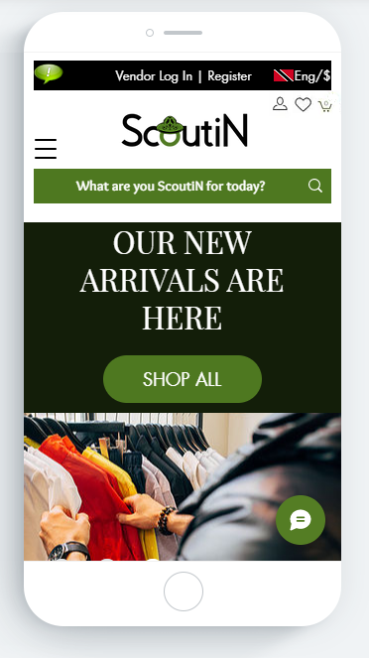

With a loading screen with our logo, like the below example. If we can get the screen to the black with the white logo, this would even be better.

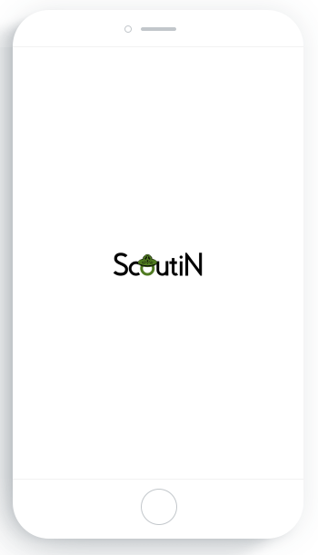

Gentle reminder that we also requested the below lightbox for the website. Below is a snipet from the communication sent regarding this.

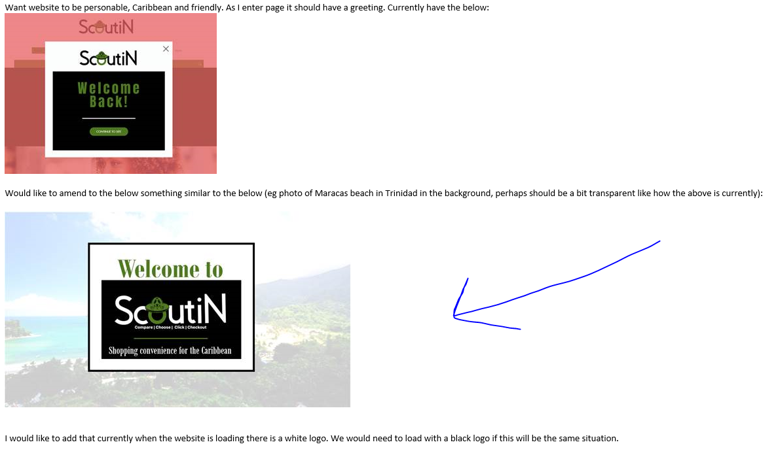

Feel free to message us at any point and we will revert soonest.

Also, please note below based on your home page updates:

1. We would like to remove the box and dollar sign int he Buy Again section we would simply like to have the title, similar to our PDF. We noticed that the product view/info was changed in the “sale” section (GREAT JOB) , but was not replicated in all of the other sections. gentle reminder that this need to be the product view for all sections. Also, is it possible to get the rating to be green like the example in the pdf?

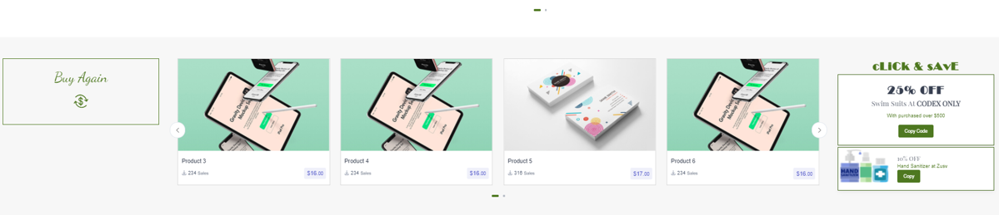

The below is what we mean when we say “product view/info”. We need to hae the same information on every product listed on the page.

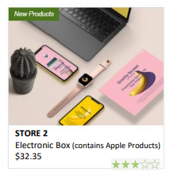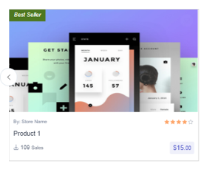

1. Sponsored items should have a title and should utilize the space of the full width as in the PDF shared, the below wasnt updated.

Yours

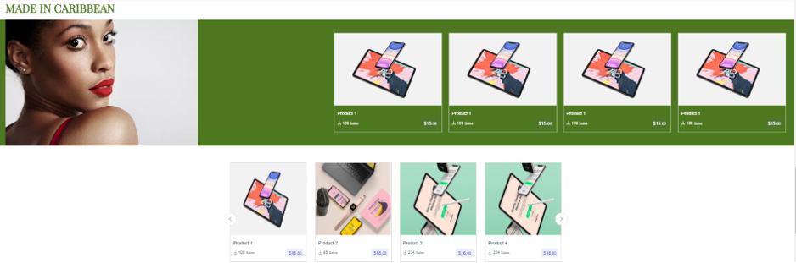

Ours

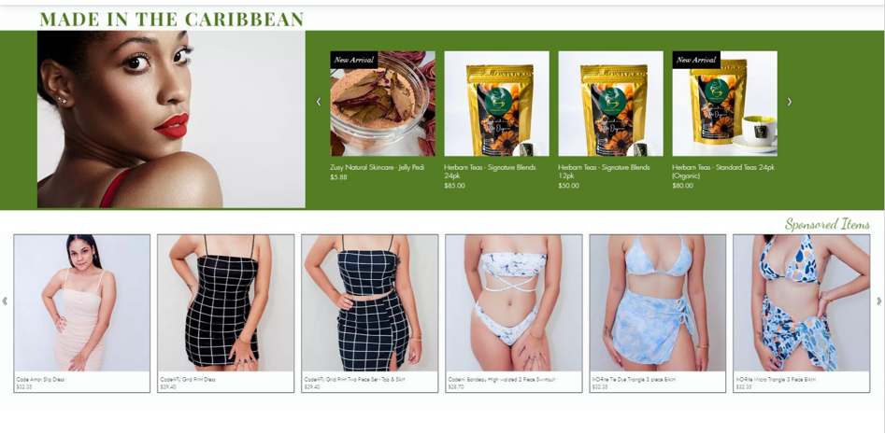

1. Trending items section not included after sponsored items, neither were the ads for this section

Yours



Ours

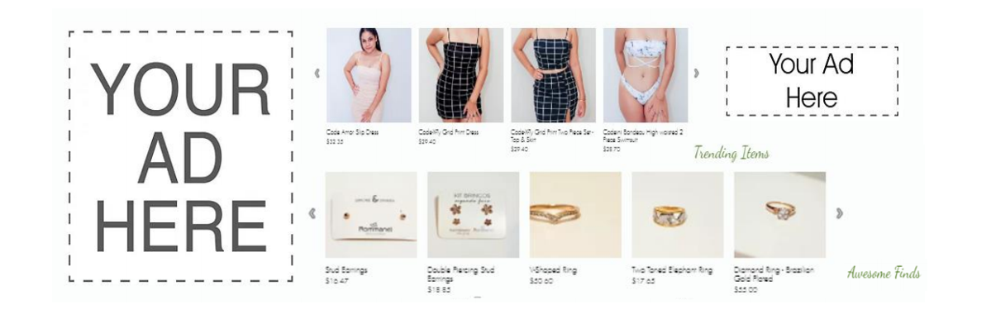

1. Be thrifty recycle logo and title need to be updated to match the PDF
2. There should be a narrow space between “who are we”, the slide show, and the footer for the page, similar to the PDF.

It would be best if you go through the PDF very carefully and make the udpates to ensure that we do not miss out anything to have to review again.

Thanks for making quick updates and sharing with us. We look forward to continue working like this.